Emax-ABAP- Day 7: 26-03-2026-
AMDP-Table Function
CDS limits:
1. We can't limit the number in the CDS view. Ex: TOP 10 records
2. SORT the data-ASC/DSC.- Not possible in CDS view.
3. Calculation Part-Not possible.

Ex for table function:
Create CDS view TF-
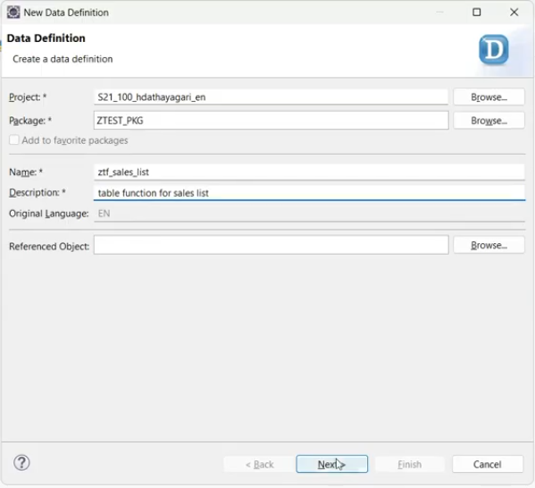
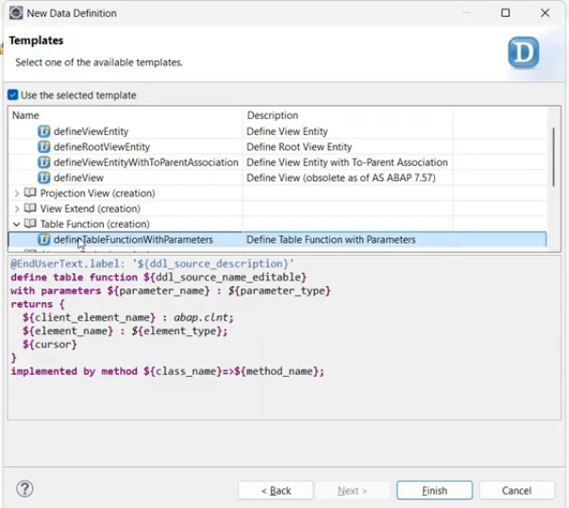
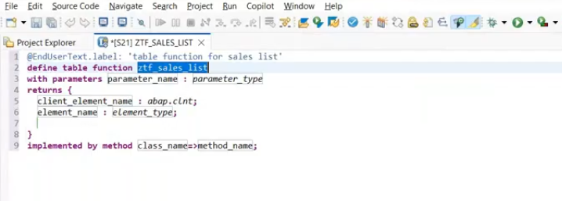
Implementation of the Table function completely done through the classes.
For table function- method is always static method only.
return parameters of table function is selection list of the cds views.
Test:- error -implementation not done.
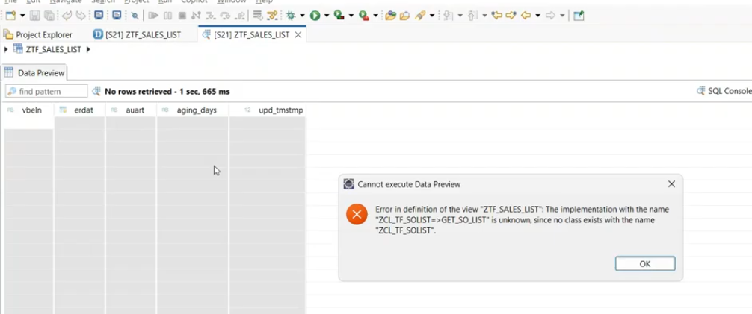
Create the TF- class:
ZCL_TF_SOLIST
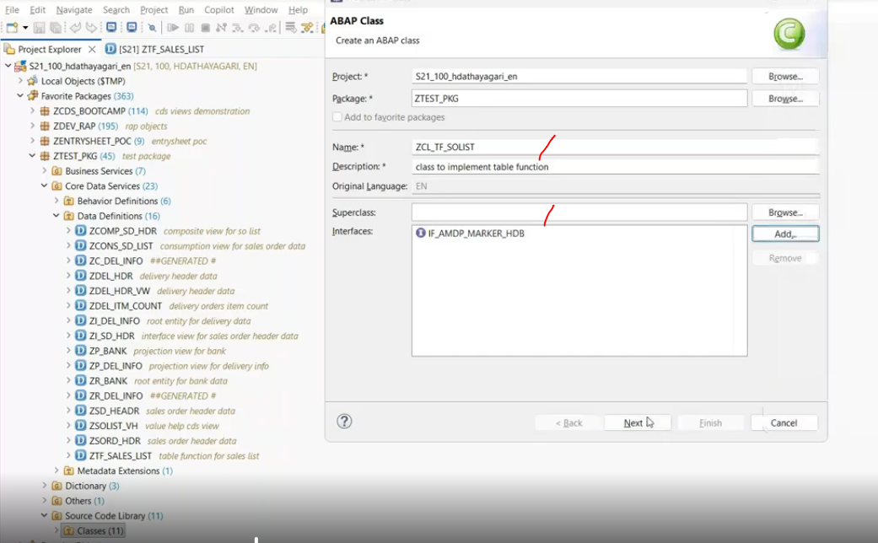
Initial Template
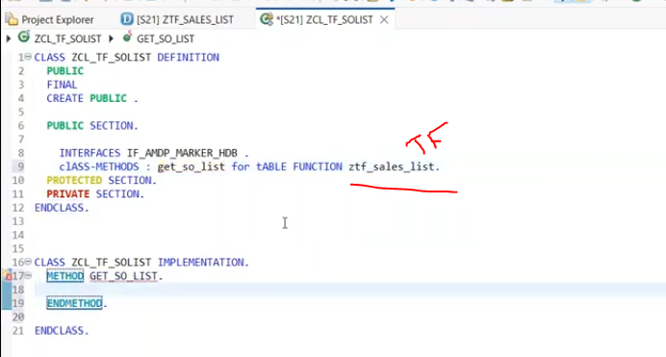

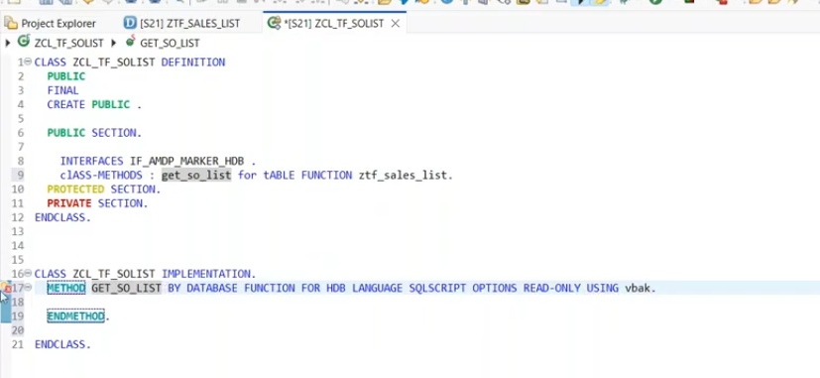
1. in table function under the returning section, you have defined all your parameters in table function( TF). Whenever you are retriving the data in the method of those class, it should be return.
2. Whatever sequence which you followed in tf return parameter, same sequence to send from the table function method otherwise through the error and
3. returning parameter name should be same as tf parameter.
Ex:
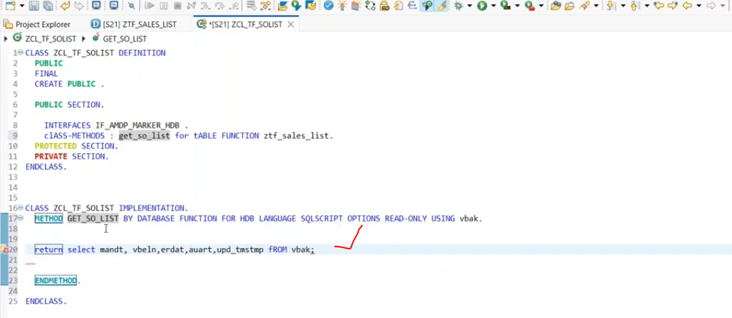
through the error message- return parameters are not same as per TF parameters.
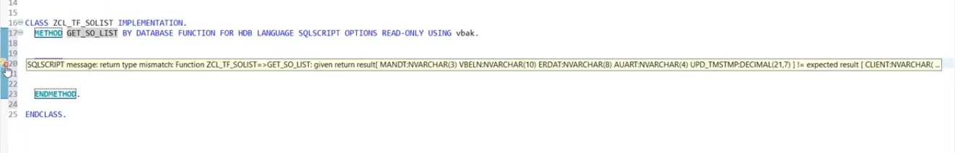
solution alias name used as tf return parameters. ( name should be equal ).
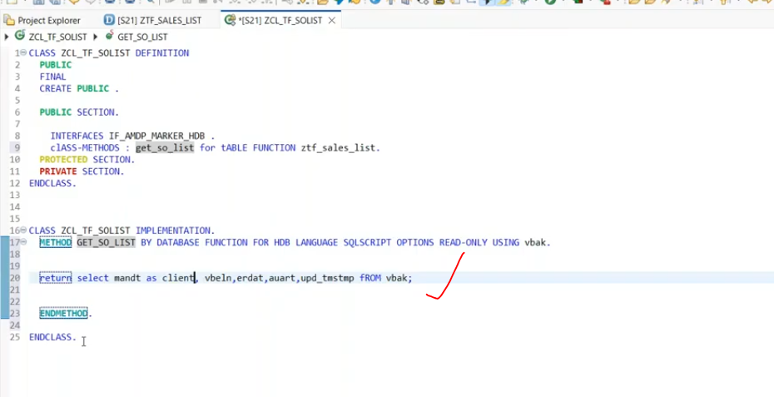
20:00
now implement the logic for days between the dates.
days_between( case when upd_tstmp is null or upd_tmstmp = '00000000' or to_nvarchar( upd_tmstmp ) = ' ' then null else to_DAte( substring( to_nvarchar( upd_tmstmp )(1, 8) , 'YYYYMMD' ) end, to_Date( to_nvarchar( current_timestamp, 'YYYYMMDD' ) , 'YYYYMMDD' ) ) as aging_Days.
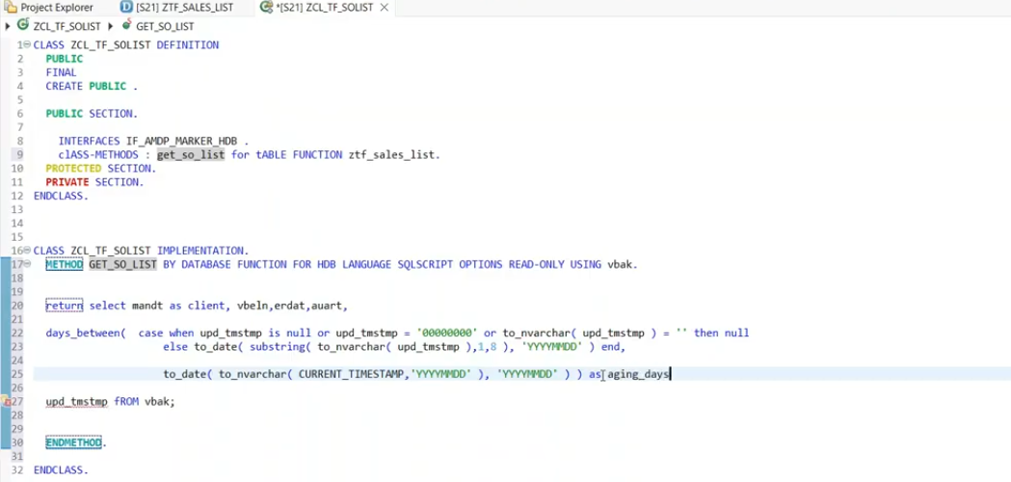
save and activate.
Now try to activate the TF also
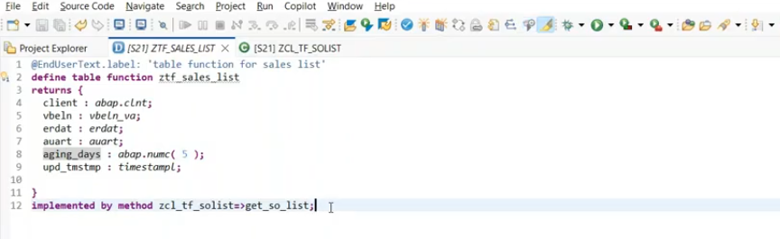
run this.
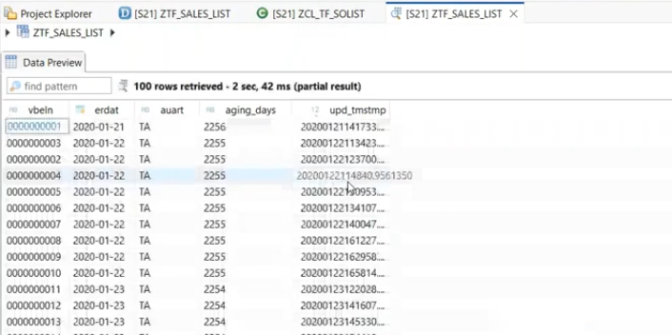
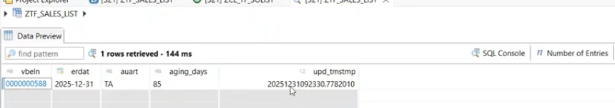

Consume the Table function in the csd view:
Now Table function can be consider to as a data source. as like as cds view.
CDS view consumed in Table function also- >=7.51
CDS view consumed in AMDP also.

DCL-Data control language.
30:00
DCL- controlling the data visibility to the user.
Pre-requisite to create the DDL first.
If we have the data, then only we can restrict to the user using access control.
Annotations: @AccessControl.authorizationCheck: #NOT_REQUIRED( no need uthorization)
@AccessControl.authorizationCheck: #CHECK- if authorization available, then check otherwise ignore.- given to full access if authorization not create.
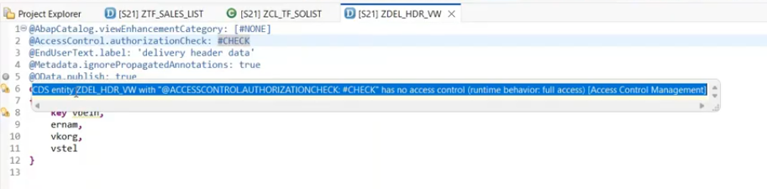

DCL creation:
-right click on the DDL(cds view)
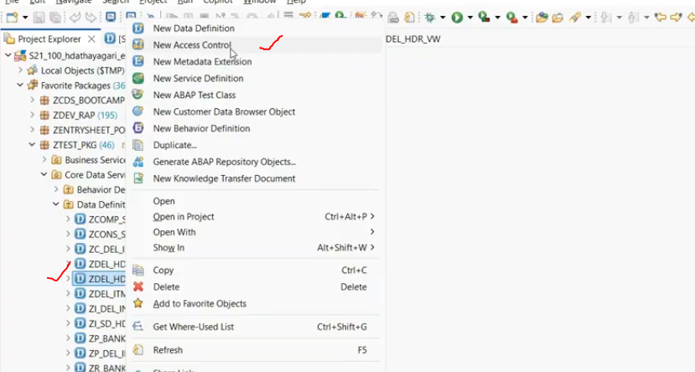
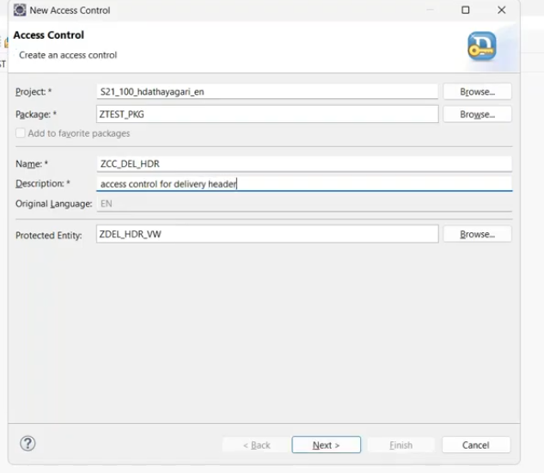
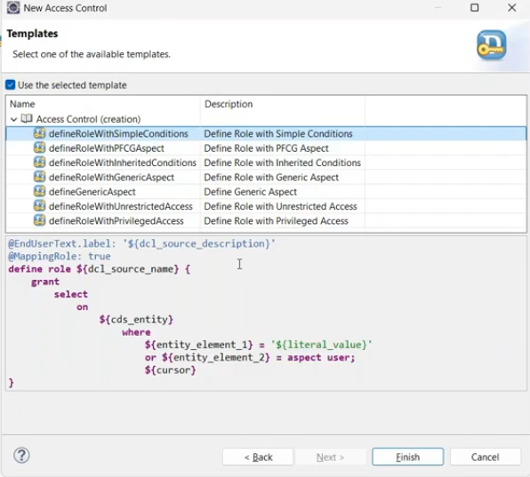
here i have chosen dcl template is simple conditions.
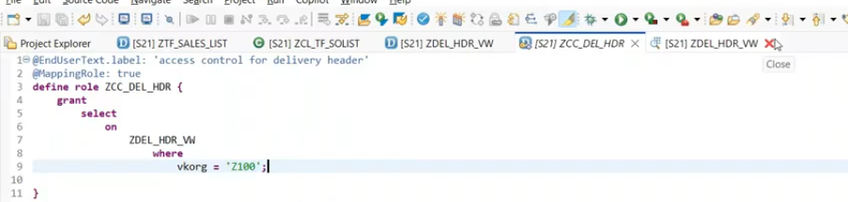
user can access only vkorg = Z100 data only.
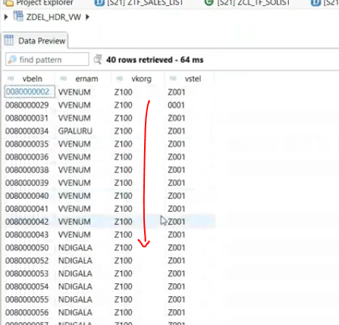
#NOT_ALLOWED - no need to create the access control.
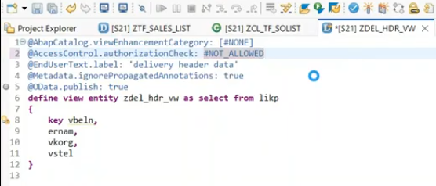
if you wanted to check access control, which is associated with the cds view- right click on the cds view
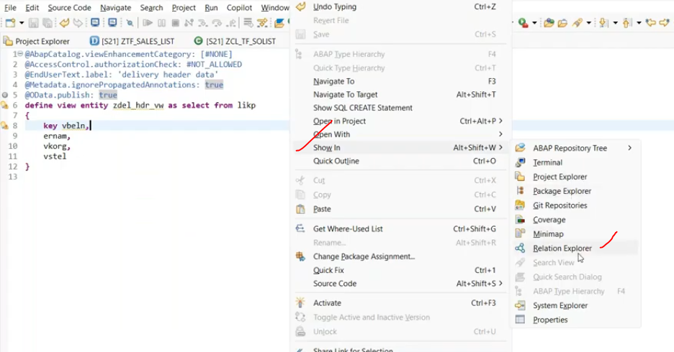
you will get the what is the dcl is assigned for that.
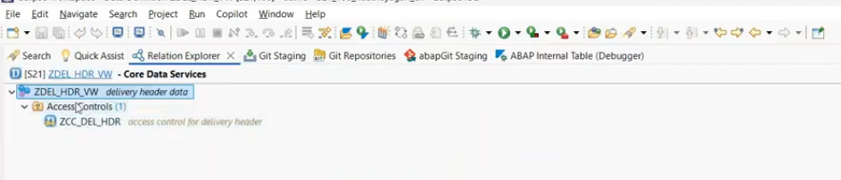
40:00

How to maintain the translations for CDS views like se63:
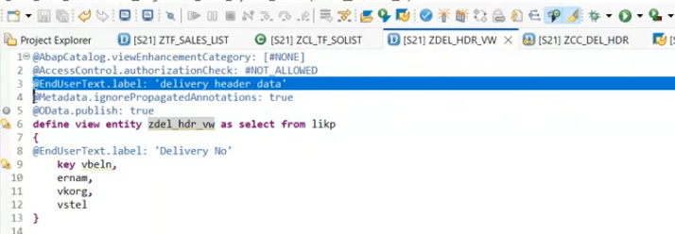
here we have two end user texts right? - CDS view description and fields description.
Go to sap screen- SE63-
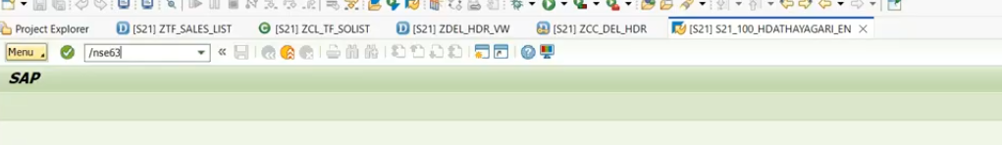
next screen- click short texts.
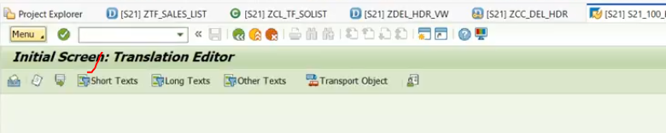
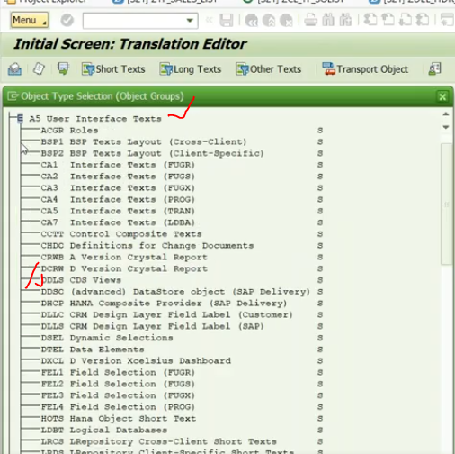
Double click on CDS views.
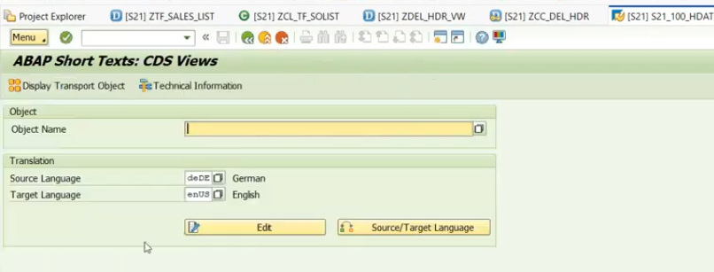
provide cds view name and select the source (EN) and target language(DE)
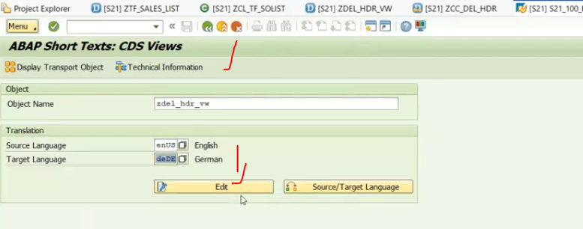
click on edit.
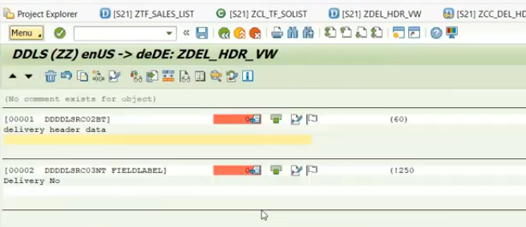
Using google translation, add the german text here. source text get it from cds view.

